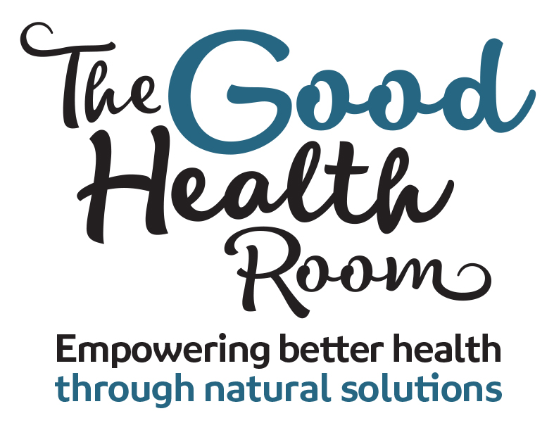

Fertility is a completely different journey for everyone. I have been there myself, I know how tough it is and I would love to help you if I can.
Before we start, please answer 4 quick questions to give me some background before we meet:
- How long have you been trying to conceive?
- Have you consulted a fertility specialist? YES (when?) / NO
- Are you considering IVF? YES / NO
- Are you prepared to adjust diet and lifestyle to conceive? YES / NO

Name: ________________________________________________________________________
Contact number: ________________________________________________________________
When is the best time for me to call you? _____________________________________________
What town / city do you live? ______________________________________________________
Thank you so much for getting in touch.
As every body’s ‘body’ is different, there is no quick fix or guaranteed success, but sending this form off is the first step on your journey to get your hormones and reproductive system functioning better, to aid better results. I really look forward to meeting you.
Please email this completed form to Shona Mackenzie at: info@thegoodhealthroom.co.nz

